**LAPORAN PRAKTIKUM**

**Routing OSPF**



Oleh:

Nama : L Hafidl Alkhair

Nim : 2023903430060

Kelas : TRKJ 2.C

Jurusan : Teknologi Informasi dan Komputer

Program Studi : Teknologi Rekayasa Komputer Jaringan

Dosen Pembimbing : Aswandi, S.Kom., M.Kom



***KEMENTRIAN RISET, TEKNOLOGI DAN PERGURUAN TINGGI***

***POLITEKNIK NEGERI LHOKSEUMAWE***

***TAHUN AJARAN 2024/2025***

1. **Tujuan Praktikum**
2. Mempelajari prinsip kerja dan cara konfigurasi OSPF untuk memastikan paket dirutekan secara optimal dalam jaringan yang dibagi berdasarkan area.
3. Mahasiswa mampu mendesain jaringan dengan menerapkan konsep OSPF.
4. **Alat dan Bahan**

* Router Cisco
* PC atau laptop
* Kabel UTP
* Kabel Serial
* Software Packet Tracer

**Langkah Praktikum**

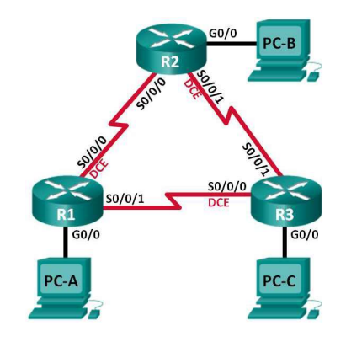**Topology**

**Addressing Table**

|  |  |  |  |  |
| --- | --- | --- | --- | --- |
| **Device** | **OSPF Router ID** | **Interface** | **IP Address** | **Default Gateway** |
| R1 | 1.1.1.1 | G0/0 | 192.168.1.1/24 | N/A |
| 2001:DB8:ACAD:A::1/64 |
| FE80::1 link-local |
|  |  | S0/0/0 | 192.168.12.1/30 | N/A |
| 2001:DB8:ACAD:12::1/64 |
| FE80::1 link-local |
|  |  | S0/0/1 | 192.18.13.1/30 | N/A |
| 2001:DB8:ACAD:13::1/64 |
| FE80::1 link-local |
| R2 | 2.2.2.2 | G0/0 | 192.168.2.1/24 | N/A |
| 2001:DB8:ACAD:B::2/64 |
| FE80::2 link-local |
|  |  | S0/0/0 | 192.168.12.2/30 | N/A |
| 2001:DB8:ACAD:12::2/64 |
| FE80::2 link-local |
|  |  | S0/0/1 | 192.168.23.1/30 | N/A |
| 2001:DB8:ACAD:23::2/64 |
| FE80::2 link-local |
| R3 | 3.3.3.3 | G0/0 | 192.168.3.1/24 | N/A |
| 2001:DB8:ACAD:C::3/64 |
| FE80::3 link-local |
|  |  | S0/0/0 | 192.168.13.2/30 | N/A |
| 2001:DB8:ACAD:13::3/64 |
| FE80::3 link-local |
|  |  | S0/0/1 | 192.168.23.2/30 | N/A |
| 2001:DB8:ACAD:23::3/64 |
| FE80::3 link-local |
| PC-A |  | NIC | 192.168.1.3/24 | 192.168.1.1 |
| 2001:DB8:ACAD:A::A/64 | FE80::1 |
| PC-B |  | NIC | 192.168.2.3/24 | 192.168.2.1 |
| 2001:DB8:ACAD:B::B/64 | FE80::2 |
| PC-C |  | NIC | 192.168.3.3/24 | 192.168.3.1 |
| 2001:DB8:ACAD:C::C/64 | FE80::3 |

**Bagian 1: Membangun Jaringan dan Memuat Konfigurasi Perangkat**

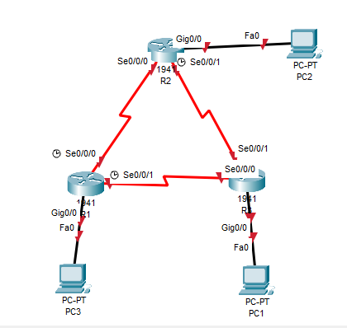**Langkah 1: Sambungkan kabel jaringan seperti yang ditunjukkan dalam topologi.**

**Langkah 2: Konfigurasikan host PC.**

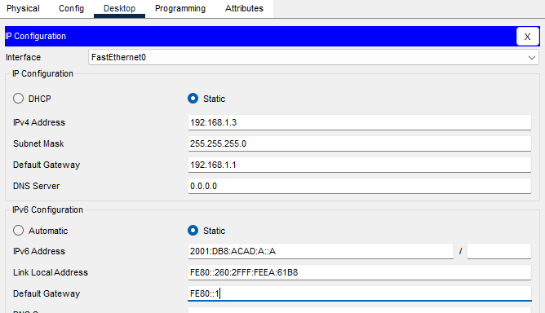**PC-A**

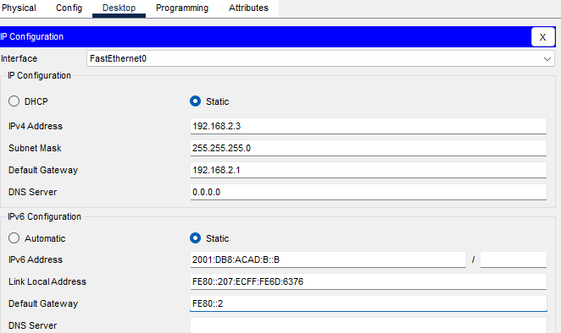**PC-B**

**PC-C**

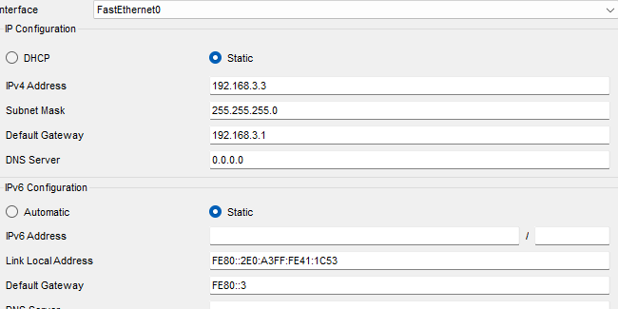

**Langkah 3: Memuat konfigurasi router.**

**Router R1 Configuration:**

*conf t*

*service password-encryption*

*no ip domain lookup*

*hostname R1*

*enable secret class*

*line con 0*

*logging synchronous*

*password cisco*

*login*

*line vty 0*

*password cisco*

*login*

*banner motd @Unauthorized Access is Prohibited!@*

*ipv6 unicast-routing*

*ipv6 router ospf 1*

*router-id 1.1.1.1*

*passive-interface g0/0*

*interface g0/0*

*ip address 192.168.1.1 255.255.255.0*

*ipv6 address 2001:db8:acad:a::1/64*

*ipv6 address fe80::1 link-local*

*interface s0/0/0*

*clock rate 128000*

*ip address 192.168.12.1 255.255.255.0*

*ipv6 address 2001:db8:acad:12::1/64*

*ipv6 address fe80::1 link-local*

*ipv6 ospf 1 area 0*

*no shutdown*

*interface s0/0/1*

*ip address 192.168.13.1 255.255.255.0*

*ipv6 address 2001:db8:acad:13::1/64*

*ipv6 address fe80::1 link-local*

*ipv6 ospf 1 area 0*

*no shutdown*

*router ospf 1*

*network 192.168.1.0 0.0.0.255 area 0*

*network 129.168.12.0 0.0.0.3 area 0*

*network 192.168.13.0 0.0.0.3 area 0*

*passive-interface g0/0*

*end*

**Router R2 Configuration:**

*conf t*

*service password-encryption*

*no ip domain lookup*

*hostname R2*

*enable secret class*

*line con 0*

*logging synchronous*

*password cisco*

*login*

*line vty 0*

*password cisco*

*login*

*banner motd @Unauthorized Access is Prohibited!@*

*ipv6 unicast-routing*

*ipv6 router ospf 1*

*router-id 2.2.2.2*

*interface g0/0*

*ip address 192.168.2.1 255.255.255.0*

*ipv6 address 2001:db8:acad:B::2/64*

*ipv6 address fe80::1 link-local*

*no shutdown*

*interface s0/0/0*

*ip address 192.168.12.2 255.255.255.252*

*ipv6 address 2001:db8:acad:12::2/64*

*ipv6 address fe80::2 link-local*

*ipv6 ospf 1 area 0*

*no shutdown*

*interface s0/0/1*

*clock rate 128000*

*ipv6 address 2001:db8:acad:23::2/64*

*ipv6 address fe80::2 link-local*

*no shutdown*

*router ospf 1*

*network 192.168.2.0 0.0.0.255 area 0*

*network 192.168.12.0 0.0.0.3 area 0*

*network 192.168.23.0 0.0.0.3 area 0*

*end*

**Router R3 Configuration:**

*conf t*

*service password-encryption*

*no ip domain lookup*

*enable secret class*

*hostname R3*

*line con 0*

*logging synchronous*

*password cisco*

*login*

*line vty 0*

*password cisco*

*login*

*banner motd @Unauthorized Access is Prohibited!@*

*interface g0/0*

*ipv6 address 2001:db8:acad:c::3/64*

*ipv6 address fe80::3 link-local*

*interface s0/0/0*

*clock rate 128000*

*ip address 192.168.13.1 255.255.255.252*

*ipv6 address 2001:db8:acad:13::3/64*

*ipv6 address fe80::3 link-local*

*no shutdown*

*interface s0/0/1*

*ip address 192.168.23.2 255.255.255.252*

*ipv6 address 2001:db8:acad:23::3/64*

*ipv6 address fe80::3 link-local*

*router ospf 1*

*network 192.168.3.0 0.0.0.255 area 0*

*passive-interface g0/0*

*end*

**Langkah 3: Melakukan tes ping**

**Ping Pc 1 ke Pc 3**

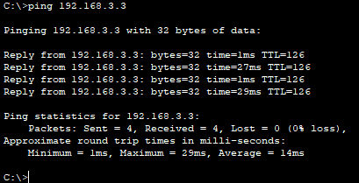

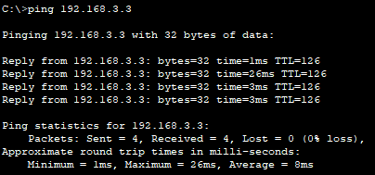**Ping Pc 2 ke 3**